**Revision for Year 7 Final Chemistry Test Name: _______________________**

*If you can answer these questions you should do well in your test.*

* Three types of mixtures – solutions, suspensions and colloids (page 119-123)
* Insoluble and soluble (page 119)
* Solute and solvent (page 121)
* 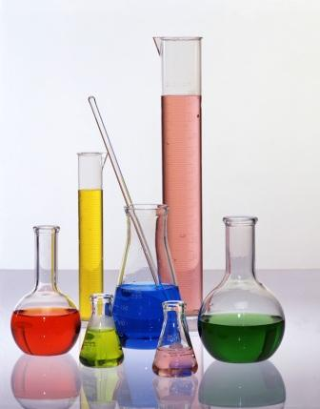Concentrated and dilute (page 121)
* Suspensions (page 122)
* Colloids – emulsion, foam, gel, sol (page 123)
* Gravity separation (page 130)
* Sieving (page 130)
* Filtration (page 130)
* Folding filter paper – conical fold, flutted fold (page 131)
* Magnetic separation (page 132)
* Centrifuging (page 133)
* Electrostatic separation (page 133)
* Chromatography (page 140)
* Evaporation (page 141)
* Distillation (page 142)
* Adsorption (page 142)
* Technique used to produce pure water for drinking – etc, desalination, waste water recycling (use assignment to help you)

**Other Study Ideas**

* Read chapters 4.1, 4.2 and 4.3 of your text book
* Make sure you have answered 4.1 unit review questions 1-17 (page 124)
* Make sure you have answered 4.2 unit review questions 1-11 (page 135)
* Make sure you have answered 4.3 unit review questions 1-7 (page 143)
* Complete 4 chapter review questions 1, 2, 4, 5, 6, 9 (page 157)
* Complete thinking scientifically questions 1, 2 (page 158)
* Read over glossary words
* Read over water assignment
* Read over notes taken in class